Chapter 2 Chemical Bonding and Molecular Structure name: class:
1. 掌握共价键和 Lewis 电子式图的绘制
Covalent bond (共价键): sharing of electron pairs between atoms
Octet rule (八电子规则): atoms tend to share electrons to achieve 8 valence electrons (except H, Be, B)
Lewis diagram: show all valence electrons — bonding pairs as lines, nonbonding pairs as dots
Steps: count total valence electrons → identify central atom (least electronegative, except H) → draw skeleton → distribute remaining electrons as lone pairs → check octet

1. Which of the following is the correct Lewis diagram for CO₂? （ ）
A C double bonded to each O, each O has 2 lone pairs
B C single bonded to each O, each O has 3 lone pairs
C C triple bonded to one O and single bonded to the other
D C double bonded to each O, each O has 3 lone pairs

2. How many lone pairs does the central atom in NH₃ have? （ ）
A 0
B 1
C 2
D 3

3. Which molecule has an expanded octet (more than 8 valence electrons) around the central atom? （ ）
A NH₃
B PCl₅
C CO₂
D H₂O

4. The AlCl₃ molecule has only 6 electrons around Al. A student proposes adding a double bond to give Al an octet.
Which statement is correct? （ ）
A The double-bond structure is better because Al achieves an octet.
B The all-single-bond structure is better because all formal charges are zero.
C Both structures are equally valid resonance forms.
D The double-bond structure is better because it has fewer formal charges.

5. This question is about Lewis structures.
(a) Draw the complete Lewis electron-dot diagram for carbon dioxide, CO₂. Show all bonding and nonbonding electron pairs. [2 marks]
(b) Nitrogen dioxide, NO₂, has 17 valence electrons. Draw a Lewis diagram for NO₂ that satisfies the octet rule for the oxygen atoms. [2 marks]

2. 掌握形式电荷和共振结构
Formal charge (形式电荷) = valence e⁻(free atom) − nonbonding e⁻ − ½(bonding e⁻)
Best Lewis structure: formal charges as close to zero as possible; negative formal charges on more electronegative atoms
Resonance (共振): when multiple valid Lewis structures differ only in electron arrangement — the actual structure is a hybrid/average
Resonance structures have identical bond lengths intermediate between single and double bonds

1. The nitrate ion, NO₃⁻, has three identical N-O bonds. This is best explained by: （ ）
A nitrogen forms one double bond and two single bonds.
B the three N-O bonds are all double bonds.
C resonance — the actual structure is an average of three equivalent resonance forms.
D formal charges make one N-O bond stronger than the others.

2. For the SCN⁻ ion, two resonance structures are possible: [S=C=N]⁻ and [S-C≡N]⁻.
Based on formal charges, which is preferred? （ ）
A [S=C=N]⁻ because S has 0 formal charge.
B [S-C≡N]⁻ because the negative charge is on the most electronegative atom (N).
C [S=C=N]⁻ because N has −1 formal charge.
D Both are equally preferred.

3. This question is about formal charge and resonance.
(a) Draw all valid resonance structures for the nitrate ion, NO₃⁻. Include formal charges on each atom. [3 marks]
(b) Explain how the concept of resonance accounts for the observation that all three N-O bonds in the nitrate ion have identical lengths. [1 mark]
(c) For the BF₃ molecule, a structure with a B=F double bond gives boron an octet. Using formal charges, explain why the structure without the double bond is preferred. [2 marks]

3. 掌握 VSEPR 理论和键角预测
VSEPR (价层电子对互斥理论): electron domains (bonding pairs + lone pairs) repel each other and arrange to maximize separation
Lone pair–lone pair > lone pair–bonding pair > bonding pair–bonding pair repulsion
Electron-domain geometry vs molecular geometry: lone pairs affect ED geometry but are "invisible" in molecular geometry
Common molecular geometries:
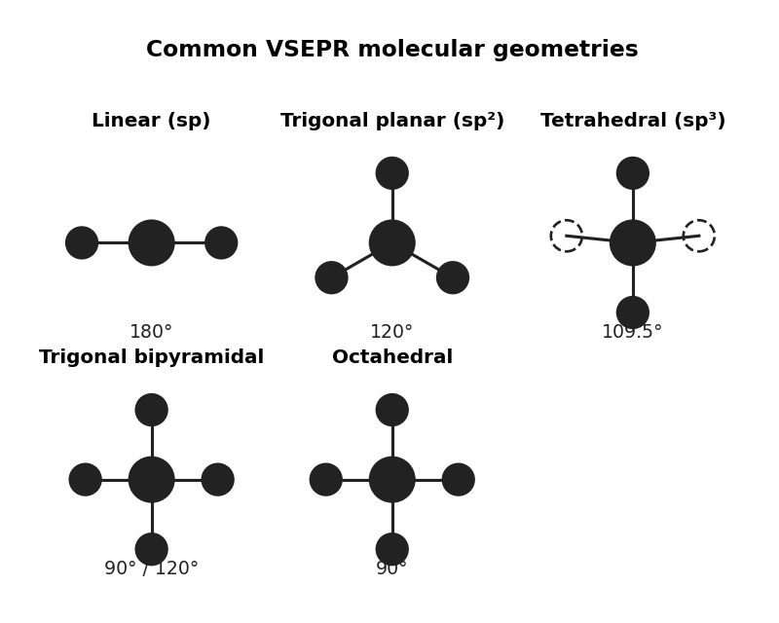
图 C₀2-3：VSEPR 分子几何形状示意（对应第 3 考点）
Expanded octet: central atoms in Period 3+ can have 5 or 6 electron domains (e.g. PCl₅, SF₆); VSEPR predicts trigonal bipyramidal (5 ED) or octahedral (6 ED) geometry
In trigonal bipyramidal geometry: lone pairs prefer equatorial positions (less repulsion)
Bonding pairs | Lone pairs | ED Geometry | Molecular Geometry | Example
2 | 0 | linear | linear | CO₂
3 | 0 | trigonal planar | trigonal planar | BF₃
3 | 1 | trigonal planar | bent (~120°) | SO₂
4 | 0 | tetrahedral | tetrahedral (109.5°) | CH₄
4 | 1 | tetrahedral | trigonal pyramidal (~107°) | NH₃
4 | 2 | tetrahedral | bent (~104.5°) | H₂O
5 | 0 | trigonal bipyramidal | trigonal bipyramidal | PCl₅
5 | 1 | trigonal bipyramidal | seesaw | SF₄
5 | 2 | trigonal bipyramidal | T-shaped | ClF₃
5 | 3 | trigonal bipyramidal | linear | XeF₂
6 | 0 | octahedral | octahedral | SF₆
6 | 2 | octahedral | square planar | XeF₄

1. The molecules CH₄, NH₃, and H₂O all have four electron domains.
Why does the bond angle decrease from CH₄ (109.5°) to NH₃ (~107°) to H₂O (~104.5°)? （ ）
A The nuclear charge increases from C to N to O.
B The number of lone pairs increases (0 → 1 → 2), increasing lone pair repulsion.
C The atoms get smaller from C to N to O.
D The bond lengths decrease from C-H to N-H to O-H.

2. NO₂⁺ is linear while NO₂ is bent. This difference is because: （ ）
A NO₂⁺ has 2 electron domains (sp, 180°); NO₂ has 3 electron domains (sp², ~134°).
B NO₂⁺ has a triple bond while NO₂ has a double bond.
C NO₂⁺ has a lone pair while NO₂ does not.
D The nitrogen in NO₂⁺ has a higher oxidation state.

3. What is the molecular geometry of SF₆? （ ）
A trigonal bipyramidal
B octahedral
C tetrahedral
D seesaw

4. 掌握杂化轨道理论
Hybridization (杂化): mixing of atomic orbitals to form new hybrid orbitals for bonding
sp: 2 electron domains → linear (180°); sp²: 3 ED → trigonal planar (120°); sp³: 4 ED → tetrahedral (109.5°)
To identify hybridization: count electron domains (σ bonds + lone pairs) around the central atom
Double/triple bonds count as ONE electron domain in VSEPR

1. What is the hybridization of carbon in CO₂? （ ）
A sp
B sp²
C sp³
D sp³ (counting each double bond as two domains)

2. The oxalate ion, C₂O₄²⁻, has each carbon bonded to two oxygen atoms and the other carbon.
What is the hybridization of each carbon? （ ）
A sp
B sp²
C sp³
D sp³ (counting each double bond as two domains)

3. The oxalate ion, C₂O₄²⁻, contains two carbon atoms connected by a single bond, with each carbon also bonded to two oxygen atoms.
(a) Draw a complete Lewis diagram. [2 marks]
(b) Identify the hybridization of each carbon atom. [1 mark]
(c) Based on your answer to (b), predict the geometry around each carbon atom. [1 mark]

5. 掌握键能和键长
Bond energy (键能): energy required to break a bond (kJ/mol); higher bond order = higher bond energy
Bond length (键长): distance between nuclei of bonded atoms; higher bond order = shorter bond
Triple bond > double bond > single bond in energy; triple < double < single in length
N-N single bond is unusually weak due to lone pair–lone pair repulsion between adjacent N atoms

1. Which bond has the highest bond energy? （ ）
A C-C single bond
B C=C double bond
C C≡C triple bond
D They all have the same bond energy.

2. The N-N single bond energy (163 kJ/mol) is significantly lower than the C-C single bond energy (348 kJ/mol).
This is because: （ ）
A N atoms are smaller than C atoms.
B N has a higher electronegativity than C.
C Each N atom has a lone pair; the repulsion between adjacent lone pairs weakens the N-N bond.
D N₂ has a triple bond, making the N-N single bond appear weaker.

3. A potential energy curve for a diatomic molecule shows minimum energy at 199 pm with a well depth of 243 kJ/mol.
These values represent the: （ ）
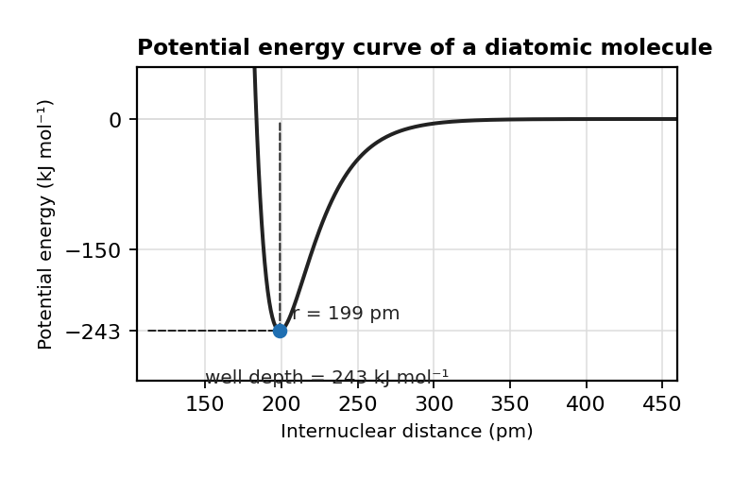
图 C₀2-1：双原子分子势能曲线（对应第 5 考点 MCQ3，r=199 pm，井深 243 kJ·mol⁻¹）
A bond length and bond angle
B atomic radius and ionization energy
C bond length and bond energy
D internuclear distance and electron affinity

4. Use the bond enthalpy data to estimate ΔH for: CH₄(g) + 2 O₂(g) → CO₂(g) + 2 H₂O(g)
(a) Calculate the total energy required to break all bonds in the reactants. (C-H = 413, O=O = 498 kJ/mol) [1 mark]
(b) Calculate the total energy released when bonds in the products form. (C=O = 799, O-H = 467 kJ/mol) [1 mark]
(c) Calculate ΔH for the reaction. [1 mark]

6. 掌握键的极性
Bond polarity (键的极性): determined by electronegativity difference between bonded atoms
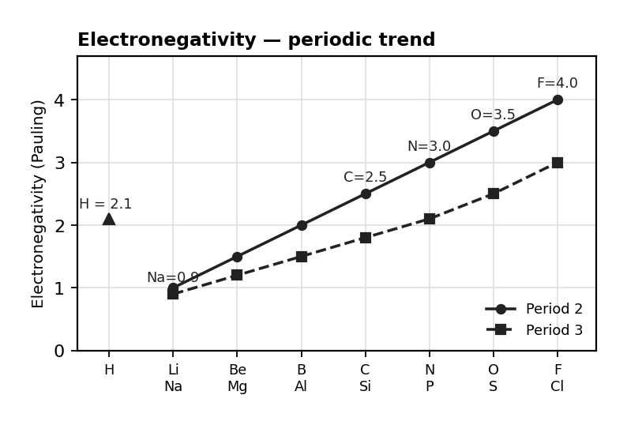
图 C₀2-2：Pauling 电负性周期趋势图（对应第 6 考点）
Nonpolar covalent: equal sharing (ΔEN < 0.4); Polar covalent: unequal sharing (0.4 < ΔEN < 1.7); Ionic: electron transfer (ΔEN > 1.7)
Dipole moment (偶极矩): vector sum of bond dipoles; symmetrical molecules can be nonpolar despite polar bonds (e.g. CO₂, CCl₄)

1. Which molecule is nonpolar despite having polar bonds? （ ）
A H₂O
B NH₃
C CCl₄
D CH₃Cl

2. Which bond is the most polar? （ ）
A C-H
B N-H
C O-H
D F-H

3. CO₂ is a nonpolar molecule. This is because: （ ）
A the C=O bonds are nonpolar.
B CO₂ is linear and the two bond dipoles cancel each other.
C carbon and oxygen have similar electronegativities.
D CO₂ only contains London dispersion forces.

4. Answer the following about bond polarity and molecular polarity.
(a) Explain why CCl₄ is nonpolar but CHCl₃ is polar. [2 marks]
(b) Predict whether CH₂Cl₂ is polar or nonpolar. Justify your answer using VSEPR theory and bond dipoles. [2 marks]

